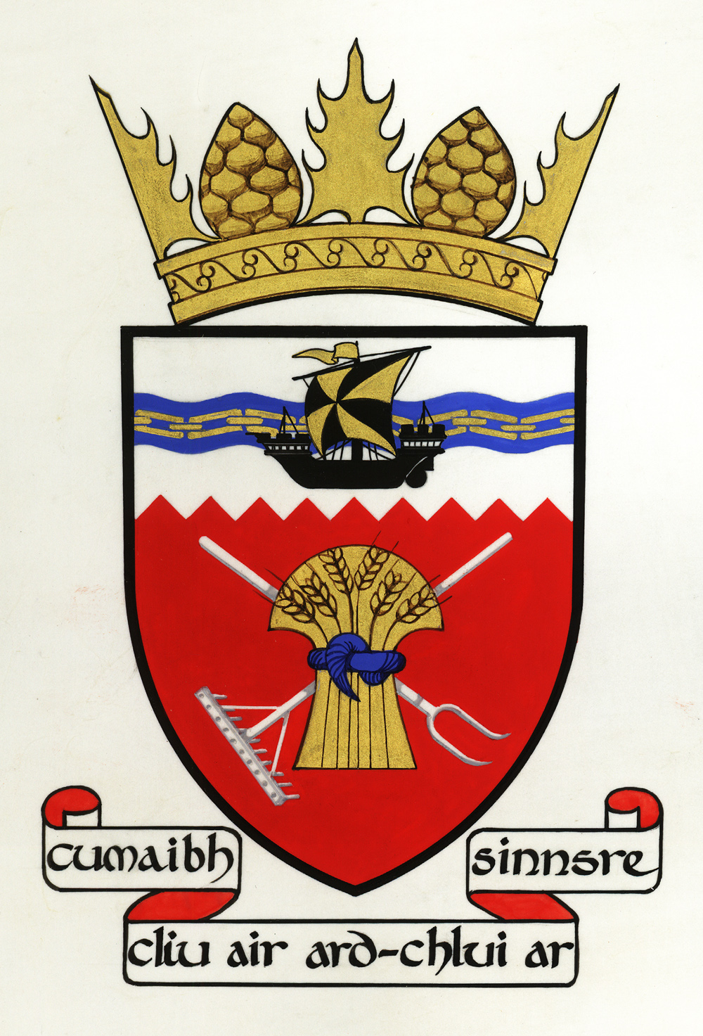

Tiree Community Council
Convenor: Phyl Meyer

Representing the community on the island of Tiree

21 September 2023

Dear Ms Compton-Bishop,

Recent changes in conditions for Tiree patients using the Highlands and Islands Patient Travel Scheme

Tiree patients needing to attend hospital in Glasgow can purchase a plane ticket themselves and claim the costs back from the Health Board, although refunds can take up to three months. Or they can apply for a ticket through the Highlands and Islands Patient Travel Scheme. For 45 years this has been administered smoothly, first on the island and subsequently at Lorn and Isles Hospital.

For the last few months, administration of the Scheme booking has moved. Since then, Tiree Community Council has received a number of complaints about a strict 48-hour rule: tickets will only be booked a maximum of two days before and two days after the medical appointment. I am told that this rule has been enforced even when the forecast is unpromising or the plane is full. This has even led to some cancelled appointments.

This restriction is making it difficult to fit in secondary appointments like bloods and X-rays generated in the principal appointment, and also visits to the dentist, solicitor or family. These other dimensions of a visit to the city also have health benefits if you live on a remote island with few local services. Islanders are telling us that travel to Glasgow for a medical appointment is now more stressful.

While the Health Board should not be paying for non-Scheme activities, the price of the return ticket for four days, forty or four hundred days is exactly the same. It is not suggested that accommodation and other expenses claimed under the Scheme should be any more than the minimum necessary. Making the scheme less restrictive will be cost neutral.

Those with £146 to buy the ticket can stay as long as they like, and then claim the money back. Those without the ability to pay upfront are therefore discriminated against.

My enquiries at the Inverness and Lochgilphead Finance Offices suggest that this is a local rule.

Tiree Community Council would like Highland Health Board to consider this matter, with a view to allowing Tiree patients who are applying to the Highlands and Islands Patient Travel Scheme to be given the opportunity to specify dates of travel that suit them.

Yours sincerely,

Dr John Holliday, Secretary, Tiree Community Council
Balephuil
Isle of Tiree
PA77 6UE
doc.holliday@tireecommunitycouncil.co.uk

This document is confidential and intended solely for the use of the addressee(s).
If you are not the intended recipient, please inform the sender immediately.
Any unauthorised use of this document is strictly prohibited.

Cc Cllr Amanda Hampsey, Chair of Argyll & Bute Integrated Joint Board

