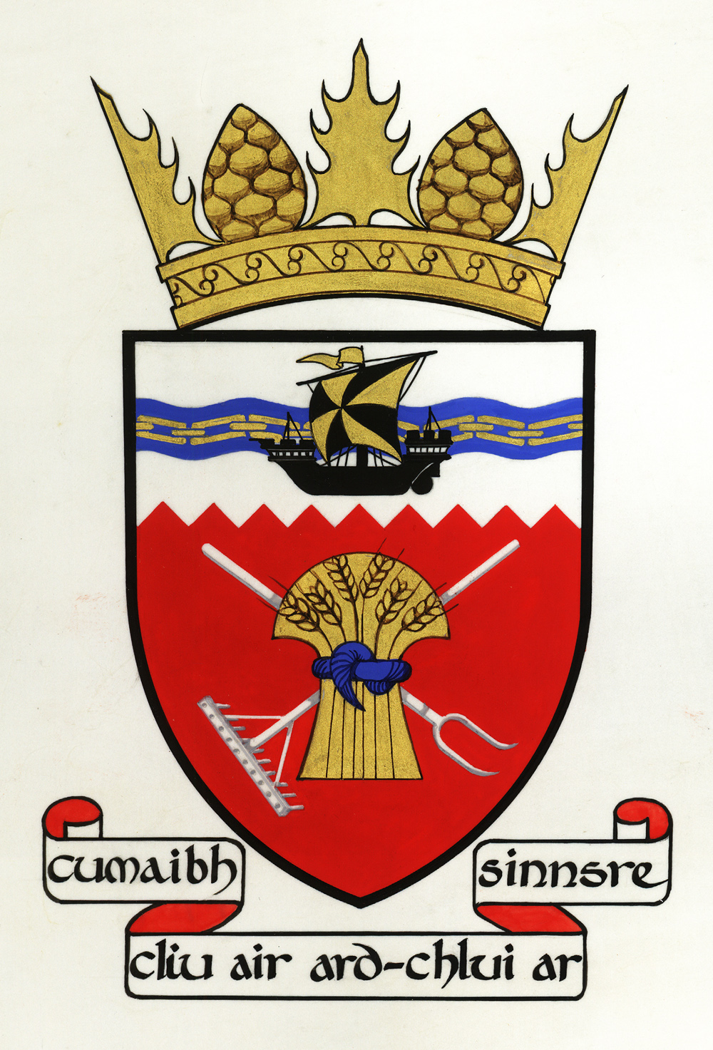

Tiree Community Council
Convenor: Dr John Holliday

7 June 2022

Representing the community on the island of Tiree

CALMAC: CHANGES TO THE TERMS AND CONDITIONS
A RESPONSE FROM TIREE COMMUNITY COUNCIL

A public consultation was initiated by a presentation from Alan Hood at our public meeting on 11 May.

In addition to the discussion that evening and the text chat – which were all critical – we solicited comments about the proposed changes and we set up an online survey using Surveymonkey. This consultation ran for two weeks.

There were 25 responses, 84% of which were from Tiree residents. 25% of respondents were happy with the changes and thought them reasonable. 75% of respondents were against the proposed cancellation charges.

Tiree Community Council therefore opposes the proposed changes to the T&Cs.

Additional points that were made to us included:
- No-shows are much more common on short routes with multiple crossings per day than on the four-hour once-daily Coll-Tiree run. As one respondent put it: ‘[The changes to the T&Cs] is a solution to a problem we don’t have.’ It was pointed out that these changes to the T&Cs should be confined to the routes where no-shows are a problem, and not on the Tiree-Coll route.
- No-shows allow islanders to travel at short notice in peak season, using the stand-by facility.
There might be a justification for these new charges for a few weeks at peak season, but not when the boat is half full or less.
CalMac should penalise persistent offenders, but not those who cancel once.
Life gets in the way. Those who live on the islands will have lots of valid reasons to cancel a booking: for example, informal child care availability or livestock issues. As one respondent told us: ‘Mainlanders would never be charged for getting a different bus to their hospital appointment.’
No-shows are partly due to the unreliability of the ferry service; passengers who can afford it sometimes make multiple bookings so they can be sure of getting away during a particular ‘window’.
It makes no sense to claw back 100% of the fare for cancelling 24 hours ahead of sailing; this offers no incentive to inform CalMac at all during that time.
Although we were told that new T&Cs were to bring CalMac into line with other Scottish ferry providers, this does not entirely seem to be the case.
Crofters and farmers can only move livestock if the weather is reasonably calm. It is not fair that they should be penalised if they cannot move their animals, and have to pay to re-book their travel arrangements.

We hope that these comments are helpful.

Your sincerely,

Dr John Holliday, Convenor, Tiree Community Council
Balephuil
Isle of Tiree
PA77 6UE
doc.holliday@tireecommunitycouncil.co.uk

This document is confidential and intended solely for the use of the addressee(s).
If you are not the intended recipient, please inform the sender immediately.
Any unauthorised use of this document is strictly prohibited.

