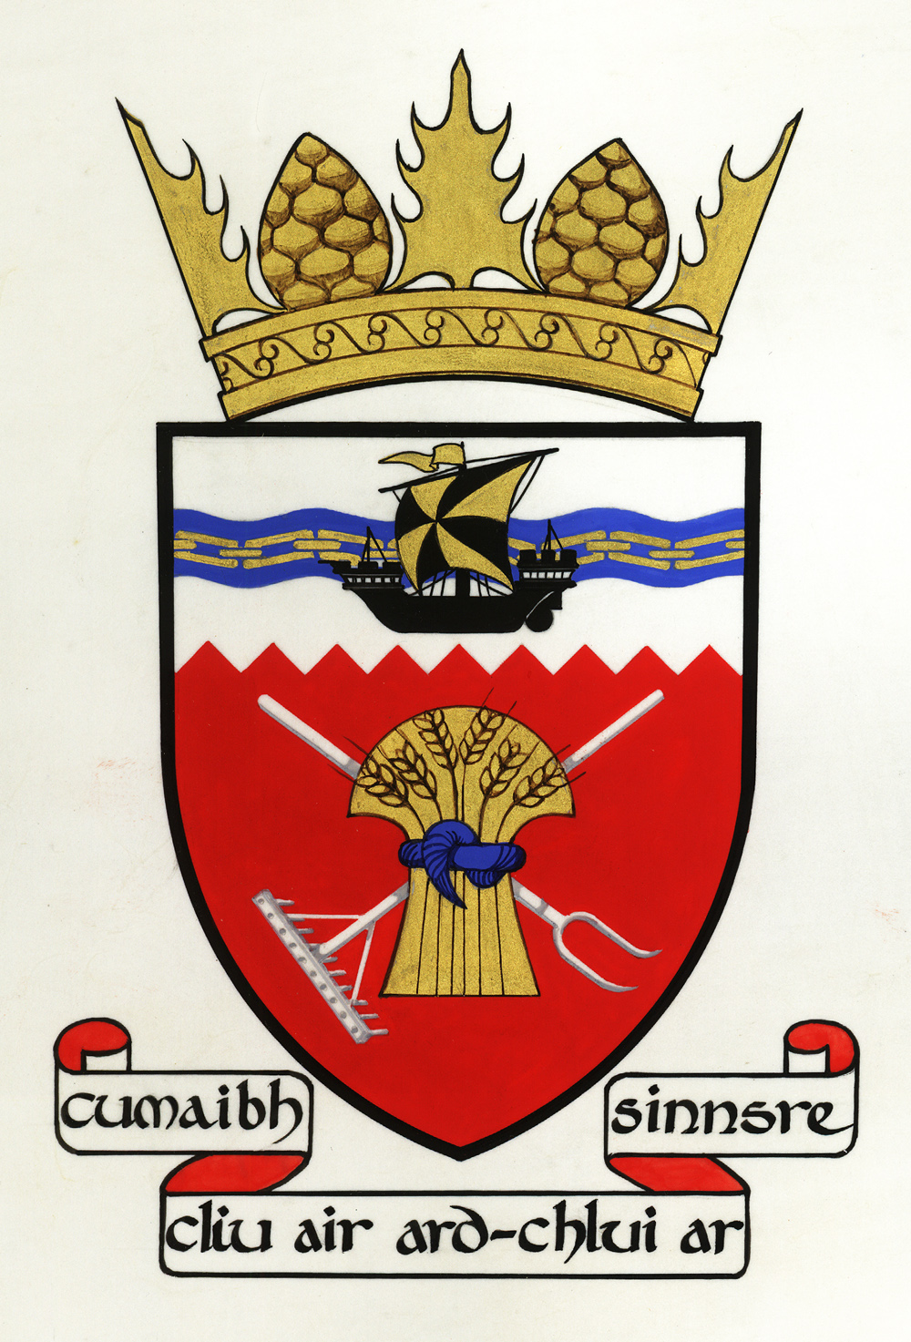

Tiree Community Council
Convenor: Dr John Holliday

Representing the community on the island of Tiree

27 February 2021

Dear Cllrs McCuish, Devon, Lynch and Mcgrigor,

The Future of Cemeteries on Tiree

Tiree Community Council has responded to the consultation on the ‘Future of Cemeteries in Argyll and Bute’, but we wanted to write to you directly as our elected representatives.

We recognise that Argyll and Bute Council has a huge cemetery estate and that it spends almost a million pounds a year on their maintenance.

To save money, the consultation paper proposes that there should be a standard configuration for any memorial border. This seems perfectly reasonable.

It also seeks to explore the use of volunteer groups to help with their upkeep. This is more problematic on this island. Two of our three graveyards are large with uneven ground; in places, there are innumerable rocks acting as grave-markers, making it difficult to stim the grass safely. In addition, all graveyards contain important ninth-century Early Christian sculpture, while one has a 1495 grave-slab which is thought to carry the earliest image of a claymore in Scotland. There is an important archaeological record here that needs to be professionally cared for.

Finally, there is a proposal to restrict the future development of cemeteries to a reduced list comprising Bute, Campbeltown/Kintyre, Dunoon, Helensburgh, Lochgilphead, Oban, Islay and Mull. The clear implication of this suggestion is that the two Tiree cemeteries will not be allowed to expand when they become full. Fortunately, this will be some time in the future: 14 years in the case of Soroby and 36 in the case of Kirkapol.

This will mean that burials after that will be in Oban. This will substantially increase funeral costs for islanders (which is in itself discriminatory) and prevent the wider community from paying their respects at the graveside. It will also split up families. The place of burial is very important to islanders, with the island still split into two parishes for the west and east end as far as committals are concerned.

The cemeteries have been in unbroken use since the twelfth century, and it is difficult to understand why this tradition cannot continue.

Tiree Community Council asks that both Tiree cemeteries are re-instated to the list of Argyll and Bute graveyards that will be expanded in the future as necessary.

Many thanks,

Dr John Holliday, Convenor, Tiree Community Council
Balephuil
Isle of Tiree
PA77 6UE
doc.holliday@tireecommunitycouncil.co.uk

This document is confidential and intended solely for the use of the addressee(s).
If you are not the intended recipient, please inform the sender immediately.
Any unauthorised use of this document is strictly prohibited.

