Result of Urgent Public Consultation on the Isle of Tiree
Tiree Community Council carried out urgent public consultation on the easing of Covid-19 restrictions via SurveyMonkey. Members of the community were asked whether they would prefer to return to December’s modified Tier 2 arrangement, which would allow for indoor socialising amongst those already on the island and permit only essential travel (Option B), or to follow the Scottish mainland into Tier 3 with fewer travel restrictions but a ban on indoor socialising (Option A). It was stated in the accompanying text that the defined options were simplifications for reference and to broadly gauge preferences, not an indication of the current timetabled plans.
Members of the community were asked to identify themselves based on the following criteria, to ensure that a broad sample of the community and their interests were represented (see Appendix I for percentage breakdown of responses by group);
- A resident of Tiree who does not own a holiday let or tourism business
- A tourism business owner who is resident on Tiree
- An owner of a holiday let who is not ordinarily resident on Tiree
- Friend or family of island resident/s, who is not ordinarily resident on Tiree
Holiday let owners and friends and family were included to represent the full diversity of the island’s economy and ‘traffic’, thus discouraging falsified responses which would skew the data. The results of the survey were as follows;
Group | Net Responses | Preference for Option A | Preference for Option B
All Responses | 322 | 141 | 181
Residents who are not business owners (Appendix II) | 229 | 92 | 137
Residents who are business owners  (Appendix III) | 44 | 20 | 24
Holiday let owners (non-resident) (Appendix IIII) | 28 | 22 | 6
Friends & Family | 21 | 7 | 14

Each demographic, except non-resident holiday let owners, favoured a more gradual easing of restrictions with continued restriction on non-essential travel.
Please see Appendices below for visualisations of the results.
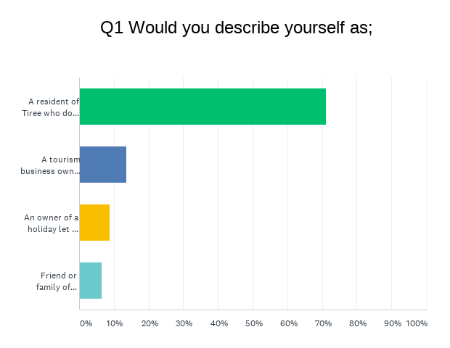
Appendix I – Total Responses

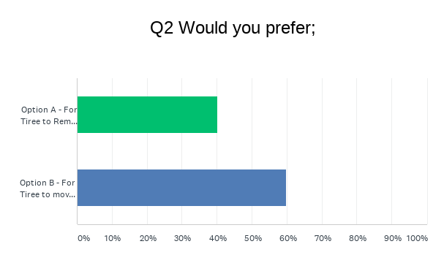
Appendix II – Non-Business Owner Resident Responses

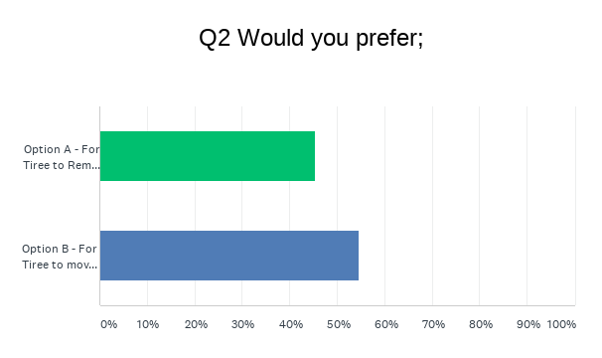
Appendix III – Tourism Business Owner Responses

Appendix IIII – Holiday Let Owners (Non-Resident)
