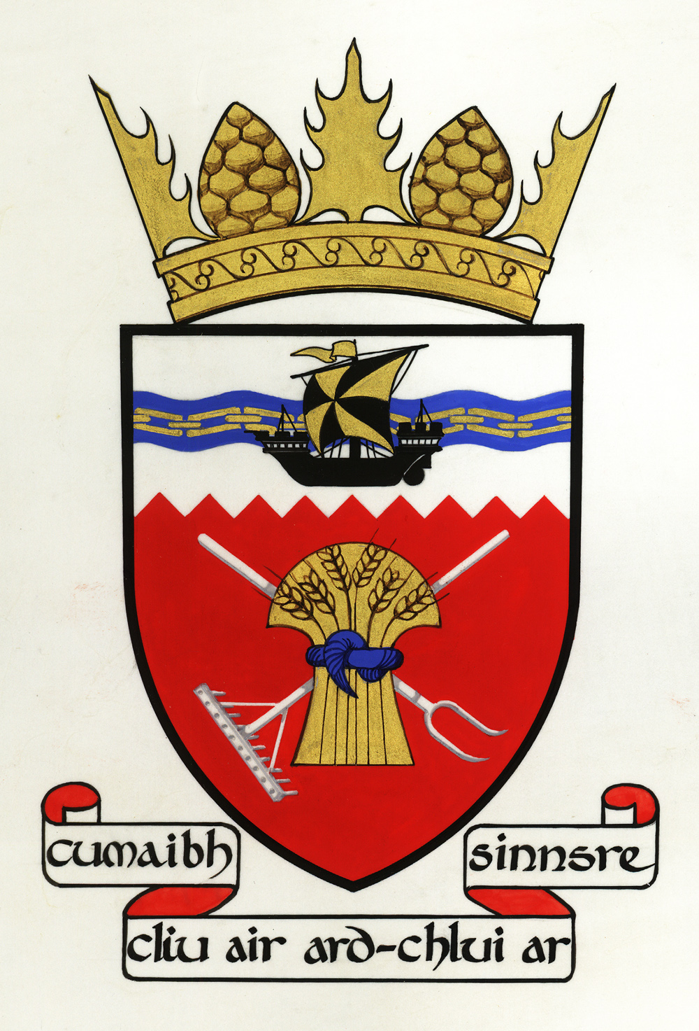

Tiree Community Council
Convenor: Dr John Holliday

Representing the community on the island of Tiree

25 June 2020

Robert Morrison
Operations Director, CalMac

Urgent Plea to Calmac from Tiree Community Council

Dear Robert,

Events are moving at dizzying speed, and we do appreciate how much the directors, management and staff of CalMac have on their plates at the moment.

Bookings on the Oban-Coll-Tiree route for the next fourteen days will open in five days time, and with the First Minister's announcement yesterday that holiday lettings will now open on 3 July – earlier than we had been led to believe – this situation is now absolutely critical.

It also needs to be said that Tiree had a very limited ferry service before lockdown, with the closure of our linkspan for three weeks, and the three named storms that battered the west coast at the beginning of the year.

We have made representations to the Cabinet Secretary for Transport. We met Michael Russell MSP the day before yesterday. At every turn, we have been assured that Scottish Government was listening to us, that the company was working on the problem and that islanders would be able to access a fair number of spaces on the ferry.

We cannot wait any longer for this situation to be resolved. Tiree Community Council needs answers to these three questions:

- Are historic bookings for July and August, currently voided, still valid? If so, will these take precedence over bookings made this summer because of the first-come-first-served principle?
- Will those whose primary residence is on the island be given an allocation of ferry tickets during July and August?
- If so, how would islanders be able to access these tickets? We want to avoid a feeding frenzy for online tickets every fourteen days, a situation that elderly islanders will inevitably lose. We advocate a facility for local people to be able to buy a limited number of return tickets at the CalMac office on the island. What we particularly want to avoid is having elderly island travellers having to queue through the night on Oban pier to be sure of a space on the return boat

We welcome the expansion of the ferry service to Tiree, provided it can be done in a safe way. We acknowledge that there will be competition for this scarce resource from hospital patients, key workers, islanders, families of those on the island, second-home owners and visitors. We just want a fair allocation of tickets for our island's residents so that they have a chance of travelling on and off the island in July and August.

We now need detailed and urgent reassurances that what we have been promised can be delivered by the company.

Yours sincerely,

Dr John Holliday, Convenor, on behalf of Tiree Community Council
Balephuil
Isle of Tiree
PA77 6UE
doc.holliday@tireecommunitycouncil.co.uk

This document is confidential and intended solely for the use of the addressee(s).
If you are not the intended recipient, please inform the sender immediately.
Any unauthorised use of this document is strictly prohibited.

