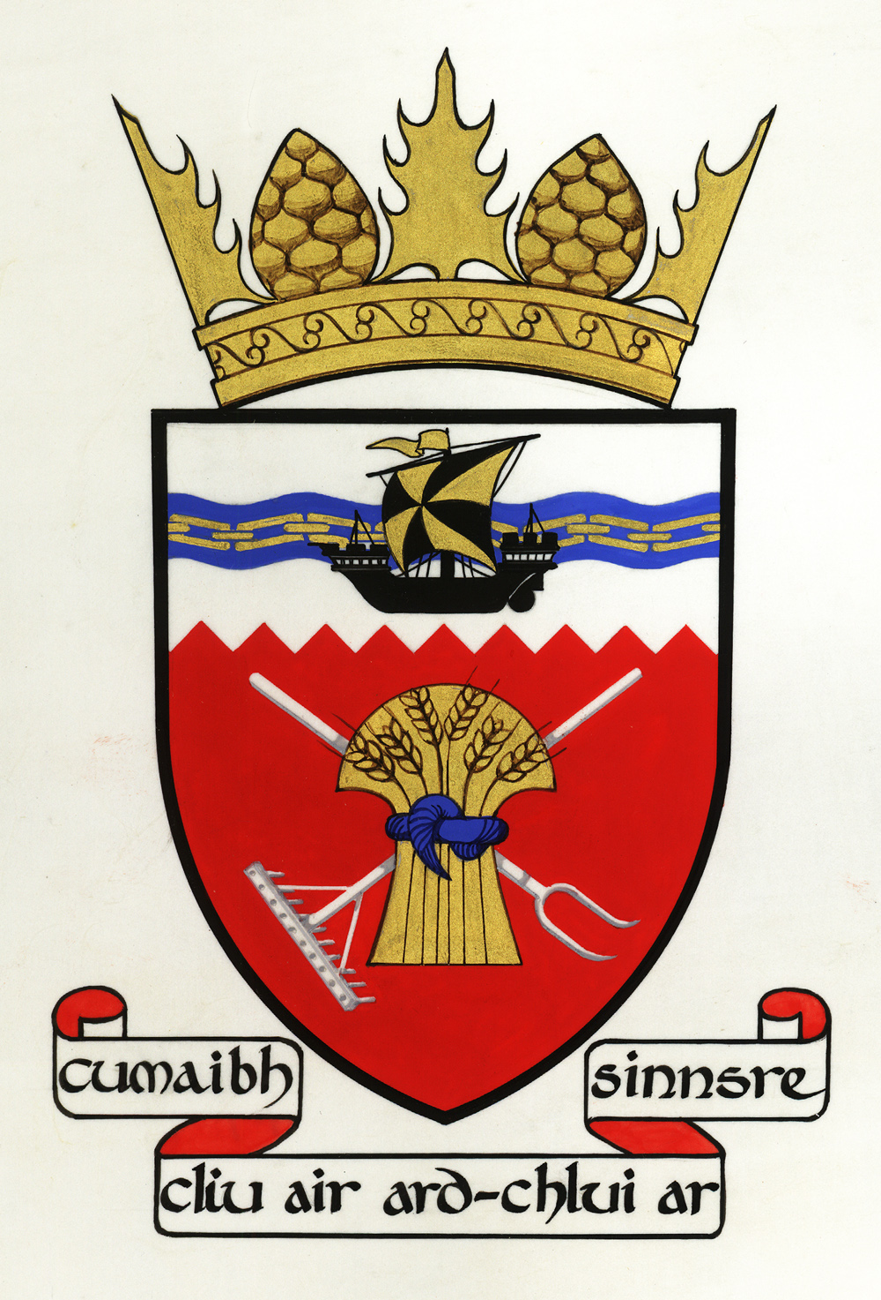

AGENDA
TIREE COMMUNITY COUNCIL PUBLIC MEETING by Zoom
Wednesday 1 July 2020 7 pm

1. Apologies
2. Conflicts of interest
3. Minutes of the last meeting and matters arising
4. Correspondence
5. Ferry update
6. Air service update
7. Scarinish phone box
8. Virtual Doors Open Day
9. Complaint about governance
10. AOCB

