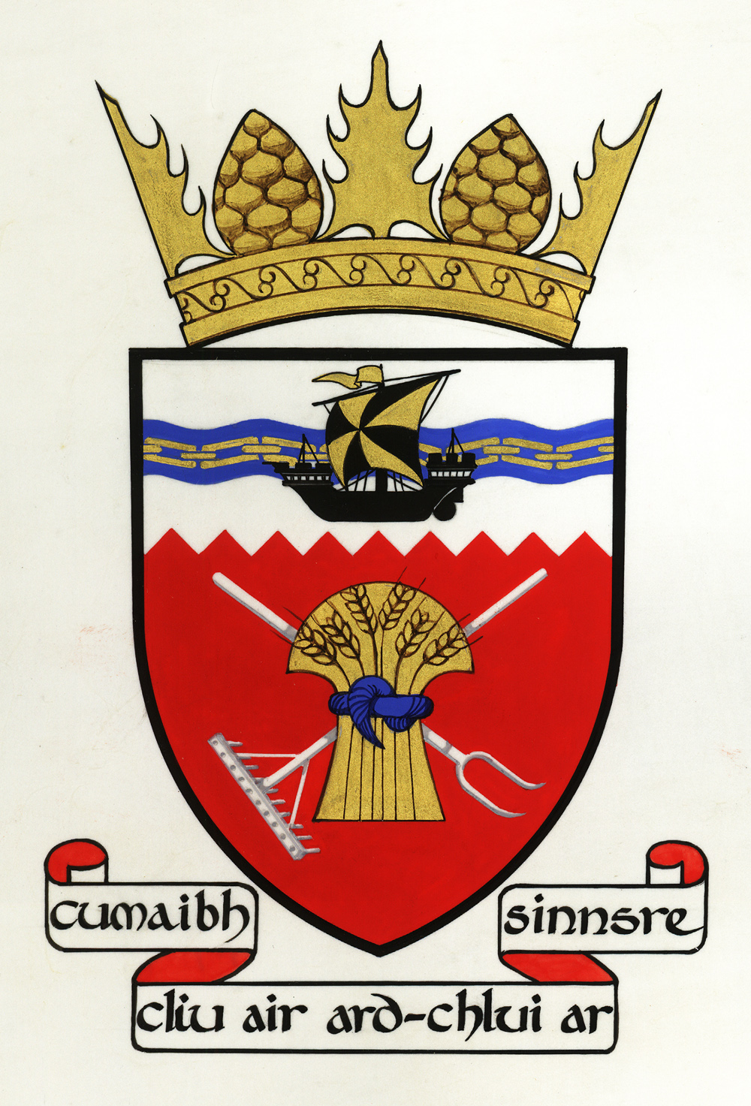

Tiree Community Council
AGENDA of PUBLIC MEETING
Wednesday 4 March 2020 7.30 pm
Large Hall, An Talla
1. Apologies
2. Declarations of interest
3. Minutes of last meeting and matters arising: roads leaflet; internet banking; patient travel; presentation by medical staff; amendment to Tiree Transport Forum minutes; erosion on Hynish road
4. Correspondence: parking and traffic flows at the pier; dialogue with Joe Reade from Mull and Iona Ferry Users' group; Tiree Community Council report to Tiree Transport Forum; progress report on linkspan replacement work; Tiree Airport runway closure; VE Day celebration
5. Report on the changes to MacLennan Motors and fuel pump operation by Catriona MacLennan
6. Land Below the Waves parliamentary reception: update
7. Constitutional position of the Tiree Transport Forum
8. Tiree planning applications in An Tirisdeach
9. Phone box project update
10. Toilets project update
11. Administration: appointment of new administrator; new actions database
12. AOCB
13. Date of next meeting: date of AGM and accounting year

