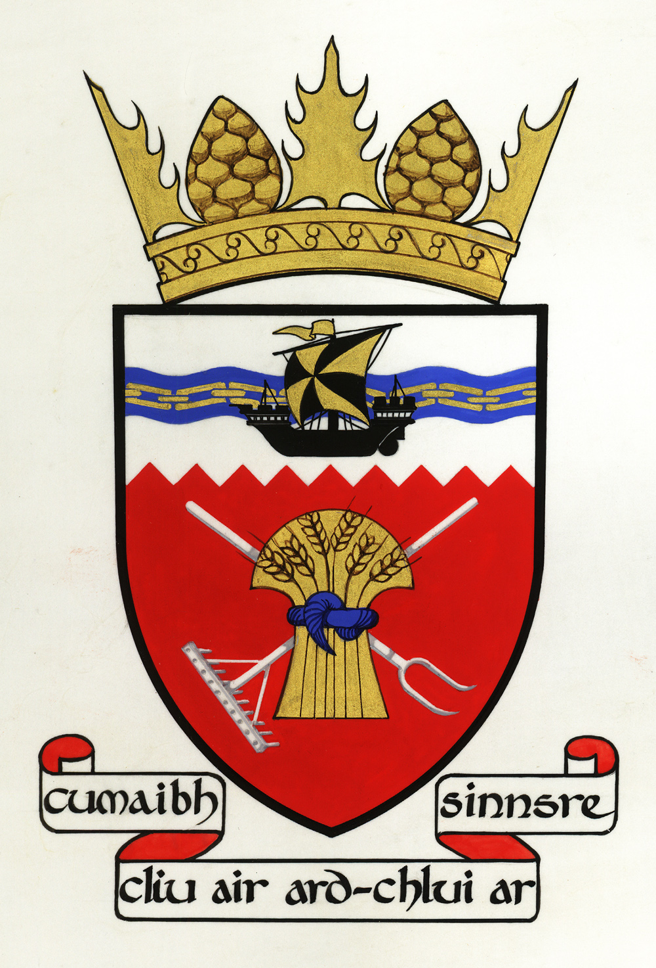

Tiree Community Council
AGENDA of PUBLIC MEETING
Wednesday 5 February 2020 7.30 pm
Large Hall, An Talla
1. Apologies
2. Declarations of interest
3. Minutes of last meeting and matters arising: including defibrillator survey and community garden
4. Correspondence: new prescription ordering system at the surgery; proposed dialogue with Joe Reade from Mull and Iona Ferry Users' group; National Planning Framework consultation; consultation on Offshore Wind projects
5. Land Below the Waves reception: report, finances
6. Linkspan replacement
7. Parking and traffic flows at the pier
8. Tiree Airport runway closure
9. SAAB replacement
10. Coll airport fire cover
11. Tiree Transport Forum meeting minutes, and other matters arising
12. Road users' guide
12. Private meeting with Argyll Estates' factor: report
13. Flag Project report
14. Remote access to meetings: audio conferencing for councillors and key agencies; broadcasting public meetings live; voting for community councillors not physically present
15. Administration: applications for administrator post; possible change of bank and new accounting methods; and new methods to capture and allocate action points from meetings
16. Website content
17. Planning applications
18. AOCB
19. Date of next meeting: date of AGM and accounting year

Reserved meeting for councillors to go through summary of actions

